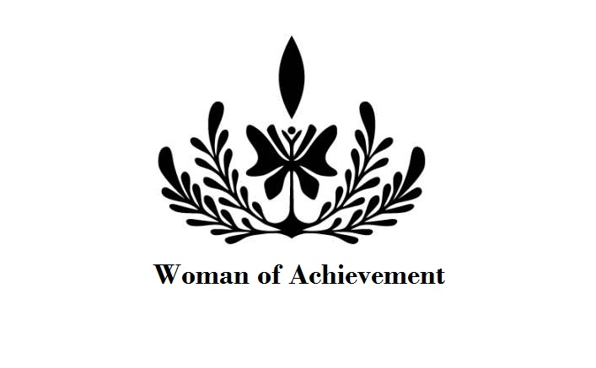
Woman of Achievement Official Entry Form

I hereby apply to represent my STATE: _________________or CITY: __________________
In the
National Woman of Achievement Pageant System

Name: ______________________________________________________________________________________
Div: Miss (19-27) ___ Ms. or Mrs. (23-39) ___ Ms. Elite or Mrs. Elite (40 & up) ____ (CIRCLE MS. OR MRS.) Address: ________________________City:_________________County_________________________________
State _______ Zip ___________Cell Phone: _________________Alt. Phone: ____________________________
Email Address: ___________________ Current Employment: _________________________________________
Name of High School or College: _________________________ State Attended: __________________________
FAMILY INFO: Husband Name (if applicable) _______________________ Children’s Names and/or Siblings:
__________________________________________________________________________________________
Past and Current Academic or Community Achievements & your plan for your platform, your reign, etc. (i.e. returning back to school and/or starting or continuing a valuable project within your community): _________________________________________________________________________________________________________________________________________________________________________________________________________________________________________________________________________________________________________________________________________________________________________________________________________________________________________________________________________________
_____________________________________________________________________________________________
College & Career—what are your college plans and/or career objectives for the future? ______________________
__________________________________________________________________________________________________________________________________________________________________________________________
What volunteer or charity works have you completed in the past two years or are currently involved in? _____________________________________________________________________________________________
_____________________________________________________________________________________________
_____________________________________________________________________________________________
If you were to win, what is the one topic you would like to emphasize to women throughout your state? YOUR PLATFORM: ________________________________________________________________________________ ____________________________________________________________________________________________
____________________________________________________________________________________________
____________________________________________________________________________________________
____________________________________________________________________________________________WHAT IS YOUR “Marketing” Plan statewide and/or nationally should you win the National Title?
How would you propose to spend your year (if you were to be selected), in order to get this message to women and others (i.e., through outreach programs, school assemblies, holding programs at YMCAs, volunteering at Senior Centers, Walks for Life, Media, etc.)—how do you propose to take your message to women throughout your state?_____________________________________________________________________________________________________________________________________________________________________________________________________________________________________________________________________________________________________________________________________________________________________________________________________________________________________________________________________________

(OPTIONAL) Other pageants you have participated in: ________________________________________________

-Page 2-

CREATIVE EXPRESSION (SPEECH or TALENT SELECTION) 1) Name your proposed talent or speech. 2) Show a Visual Media (oil painting, photography display, or other non-performance art) or 3) Perform a Talent (i.e., Vocal, ballet, instrumental, modern dance, violin, dramatic monologue, etc.) Please LIST what you will plan to present at the pageant:
_______________________________________________________________________________________________________________________________________________________________________________________________________________________________________________________________________________________
How did you hear about us? ______________________________________________________________________

What three words describe you best: 1) 2) 3)

What are you most thankful about in your life? _______________________________________________________________________________________________________________________________________________________________________________________________________________________________________________________________________________________
What is one of the biggest challenges you’ve had to overcome in life? __________________________________________________________________________________________________________________________________________________________________________________________
What would you most like to be remembered for? (What is your “life legacy” for those in your family?)
_______________________________________________________________________________________________________________________________________________________________________________________________________________________________________________________________________________________
What do you hope to gain from your pageant experience? ______________________________________________
_______________________________________________________________________________________________________________________________________________________________________________________________________________________________________________________________________________________
Why did you choose our pageant? _________________________________________________________________
__________________________________________________________________________________________________________________________________________________________________________________________

SECONDARY TITLES I am interested in if my city or state representative has been selected:
[Must have lived, attended school or have owned property in the states/regions listed below]

1st Choice: ________________________________________
2nd Choice: ________________________________________
3rd Choice: ________________________________________

THE ABOVE INFORMATION IS TRUE AND CORRECT TO THE BEST OF MY KNOWLEDGE. I agree to the categories and age divisions as stated on this application.

Signature: __________________________________________ Date: _________________________

Enclose a recent headshot or photo or email via info@womanofachievement.com $205 application fee to reserve a State Title or U.S. Regional Title OR $295 for crown and double rhinestone sash. Paypal: Martinent1@gmail.com. Money order/checks payable to: Woman of Achievement, 333 W. Garvey Avenue, Suite #3 Monterey Park, CA 91754.

Postmark Deadline: Please mail this application by____________________________

